**E-Commerce Website**

**For**

**Your IT Center**

# Title Page

**BY**

**Rohan Phuyal**

**7-2-551-230-2020**

National College of Computer Studies

*A Summer Project Report Submitted to*

**Faculty of Management, Tribhuvan University**

in partial fulfillment of the requirements for the degree of

**Bachelor of Information Management**

Paknajol, Kathmandu

June/2024

# STUDENT DECLARATION

This is to certify that I have completed the Summer Project entitled “E-Commerce Website for Your IT Center” under the guidance of “Mr. Sumit Ghising” in partial fulfillment of the requirements for the degree of Bachelor of Information Management at Faculty of Management, Tribhuvan University. This is my original work and I have not submitted it earlier elsewhere.

Date: June 2024

Signature:

Name: Rohan Phuyal

# CERTIFICATE FROM THE SUPERVISOR

This is to certify that the summer project entitled “E-Commerce Website” is an academic work done by “Rohan Phuyal” submitted in the partial fulfillment of the requirements for the degree of Bachelor of Information Management at Faculty of Management, Tribhuvan University under my guidance and supervision. To the best of my knowledge, the information presented by him in the summer project report has not been submitted earlier.

Signature of the Supervisor

Mr. Sumit Ghising

Supervisor

June 2024

# ACKNOWLEDGEMENT

I would like to express my appreciation and gratitude to the individuals whose guidance, support, and encouragement played a crucial role in the success of this project. I am thankful to the National College of Computer Studies (NCCS) for providing me with the opportunity to participate in this endeavor. Additionally, I extend my sincere gratitude to my summer project supervisor, “Mr. Sumit Ghising”, for his invaluable guidance, constructive comments, and insightful suggestions throughout the duration of this project.

Furthermore, I wish to acknowledge the support and coordination provided by “Mr. Ramesh Phuyal”, the project coordinator. His assistance was instrumental in the seamless execution of this project, and his contributions are deeply appreciated.

I also extend my gratitude to the individuals associated with "Your IT Center" for generously sharing insights into their organization, daily operations, and the challenges they currently face. Their input significantly contributed to the completion of this project by offering valuable suggestions for the best software solutions to address their needs.

Sincerely,

Rohan Phuyal

# EXECUTIVE SUMMARY

The E-commerce System is a platform that helps the organization to showcase and sell products online. As each transaction plays a vital role in driving sales, maintaining the records in a digital form will be more reliable and secure. The project aims to address the lack of online presence, which significantly curtails the reach to potential customers who are not geographically located near the physical store.

The proposed solution involves the development of an e-commerce system. The system allows the customers to browse, search, add products to cart and checkout using secured payment method or cash on delivery. Users are able to add products to cart without login but to place an order user have to login.

This system provides user friendly interface which helps to access information regarding accessories and components provided by the company. Customers can browse all the available products along with their description, image and price from which they can add their preferred product to cart and make purchase using either Khalti or Cash on Delivery. Alongside customers can also view their order history, the receipt of their purchase and can search the product.

Your IT Center’s e-commerce website is a useful and effective option that can help the store optimize its operations. Handling customer and keeping track of orders is made simple by the system's intuitive features. The system enhances customer satisfaction by providing a seamless online shopping experience.

# TABLE OF CONTENTS

*TITLE PAGE i*

*STUDENT DECLARATION ii*

*CERTIFICATE FROM THE SUPERVISOR iii*

*ACKNOWLEDGEMENT iv*

*EXECUTIVE SUMMARY v*

*LIST OF FIGURES viii*

*LIST OF TABLES ix*

*ABBREVATIONS x*

Chapter I Introduction 1

1.1 Background 1

1.2 Introduction of the Organization 1

1.3 Current Status of The Organization 1

1.4 Problem Statement 1

1.5 Objectives 1

1.6 Methodology/Procedure adopted for writing the report 1

1.6.1 Project Framework 2

1.6.2 Data and Information 2

1.6.3 Tools Used 3

1.6.4 Techniques of Project report analysis 3

Chapter II Tasks and activities performed 4

2.1 Analysis of Tasks, Activities, Problem and Issues 4

2.1.1 Analysis of Task and Activities 4

2.1.2 Analysis of Problems and Issues 4

2.2 Analysis of Possible Solutions 4

2.2.1 Requirement Analysis 4

2.2.2 Functional Requirement 4

2.2.3 Non-Functional Requirement 6

2.3 Feasibility Study 6

2.3.1 Technical Feasibility 7

2.3.2 Economic Feasibility 7

2.3.3 Operational Feasibility 7

2.3.4 Legal Feasibility 7

2.3.5 Schedule Feasibility 7

2.4 System Design 8

2.4.1 ER Diagram 8

2.4.2 DFD Diagram 9

2.5 System Testing 9

2.5.1 Unit Testing 9

2.6 Findings 12

Chapter III Discussion and Conclusion 13

3.1 Discussions 13

3.2 Conclusion 13

References 14

Appendices a

# LIST OF FIGURES

Figure 1.1 Waterfall Model 2

Figure 2.1 Use Case Diagram 5

Figure 2.2 ER Diagram 8

Figure 2.3 DFD (Level 0) 9

Figure 2.4 DFD (Level 1) 9

# LIST OF TABLES

Table 2‑1 Tools Used 3

Table 2‑1 Use Case Description 6

Table 2‑2 Gantt Chart 7

Table 2‑3 Test Case 1 10

Table 2‑4 Test Case 2 11

# ABBREVATIONS

|  |  |
| --- | --- |
| **BIM** | Bachelor of Information Management |
| **CSS** | Cascading Style Sheet |
| **COD** | Cash on Delivery |
| **ER** | Entity Relationship |
| **GUI** | Graphical User Interface |
| **HTML** | Hypertext Markup Language |
| **MYSQL** | My Structured Query Language |
| **PHP** | Hypertext Preprocessor |
| **TU** | Tribhuvan University |

# Introduction

## Background

In a digital world where online shopping reigns supreme, Your IT Center, a Kathmandu-based provider of custom desktops and PC components, lacks an online presence. This project aims to bridge this gap by developing an e-commerce website, streamlining customer interactions and sales processes. This initiative addresses the challenges of relying solely on physical store visits, limiting its reach and hindering efficient order management. By embracing e-commerce, Your IT Center hopes to expand its customer base, increase sales and brand awareness, and offer a convenient shopping experience, ultimately solidifying its position in Nepal's evolving e-commerce landscape.

## Introduction of the Organization

Your IT Center, established in 2018 and located in New Road, Kathmandu has been providing services of building custom desktop and selling PC accessories and components on Nepal. The products are completely genuine and they have been building computer for long period of time which makes them one of the best shops to build a desktop or get any computer accessories and peripherals for your home or offices.

With the growth of demand of technology, people seem to need pc and components. Whether they're a gamer in pursuit of ultimate performance, a creative professional demanding precision and speed, or a business seeking reliable computing solutions, Your IT Center’s experts are there to guide them every step of the way. They are providing components of internationally known brands such as HP, Canon, Razer, Logitech, MSI, etc.

## Current Status of The Organization

The organization has been selling components/accessories regularly along with building custom desktops. Customers were required to visit the physical store for purchase of the product and the customers had to call or contact on social media to get information about product availability. Overall, they lacked an e-commerce website.

## Problem Statement

Although “Your IT Center” have been doing well on market, there is still some problems as they were using physical store to showcase their product and there was no means to inform user about the availability of the products. Customers needed to be presence physically to purchase any product. Some of the problems are mentioned below:

* Lack of online presence significantly curtails the reach of potential customers who are not geographically located near the physical store
* Lack of customer insights due to absence of purchase history

## Objectives

The objectives of developing this software are as follows:

* To create an e-commerce website where customers can search, view and order it using the website.
* To implement the capability for admin to access order history.
* To streamline the purchase process.

## Methodology/Procedure adopted for writing the report

The methodology for this report focused on clarity, accuracy, and relevance, employing interviews to understand Your IT Center's needs. Following the Waterfall Model, the project advanced through clear phases, ensuring systematic progress from requirements gathering.

### Project Framework

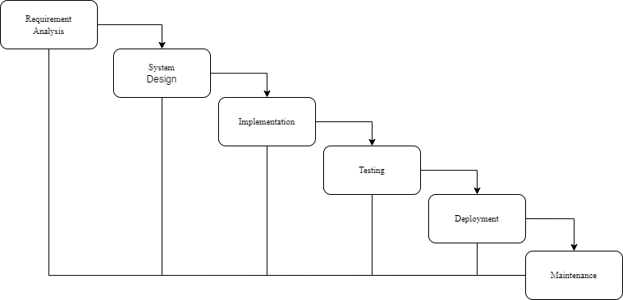

Figure 1.1 Waterfall Model

The selection of the waterfall model for this project is based on its structured approach, providing clear phases from requirements to deployment. Its sequential nature facilitates systematic progress tracking and ensures adherence to timelines. However, it may not be ideal for projects with dynamic requirements, where iterative methodologies could offer greater flexibility.

#### Requirement Gathering

Requirement gathering served as the foundational stage of the project, where a comprehensive understanding of organizational needs and user expectations was sought. Through interview, and observation, key requirements were identified, including the problem the organization was facing and what things can be implemented to overcome the problems.

#### System Design

The system design phase focused on translating requirements gathered during the initial stage into a tangible blueprint for the e-commerce website. Mockups were created to visualize the user experience and ensure intuitive navigation. Database was designed along with use case of the e-commerce website.

#### Implementation

Implementation marked the transition from conceptualization to realization, where the design specifications were translated into functional software components. Using scripting languages identified during the design phase, the e-commerce website's frontend and backend were constructed. Database structures were implemented.

#### Testing

Testing constituted a crucial phase aimed at validating the functionality, usability, and performance of the developed e-commerce website. Testing methodology, including unit testing was employed to identify and rectify defects and inconsistencies. Test cases were meticulously designed to simulate real-world scenarios and ensure the robustness and reliability of the system.

The project is yet to be deployed and maintained.

### Data and Information

Methods for collecting data are, with either quantitative approach or qualitative approach, for the completion of the project and report these following methods under primary and secondary are used:

#### Primary Data Collection

The primary data generally includes the information about services provided by the organization. These data are collected directly from the source of information without mediator. The source of data for this project is manager of “Your IT Center”. Under Primary data collection, one approach is classified in the basis of volume and quality of data collected.

##### Qualitative Approach

Qualitative approach focuses on the quality and source of the data rather than quantifying mass data and rejects the mathematical calculation. Some methods used to find conclusion of this project are:

**Observation Method** is employed by closely observing the workflow and operational procedures within the office of "Your IT Center," allowing for a detailed understanding of daily activities and interactions among staff and clients.

**Personal Interview** with manager of “Your IT Center” to understand more about the organization and all the Leo clubs they are handling. Set of Questionnaires are prepared with short, simple, and logically sequenced questions and used in interviews. The questionnaires that are asked for the report is included in Appendix 1 of this report.

#### Secondary Data Collection

Data collection from secondary sources involved reviewing currently available e-commerce website to get gist of how they are handling or implementing some functions on their e-commerce website. Researches were done on Internet to get any information for the completion of the project.

### Tools Used

For this project, the following programming and scripting languages were utilized for both the Front-End and Back-End development.

Table 2‑1 Tools Used

|  |  |  |
| --- | --- | --- |
| FRONT END | BACK END | DATABASE |
| HTML | PHP | MySQL |
| CSS |
| JavaScript |

### Techniques of Project report analysis

To analyze the issues and the problems of the report there are various process or techniques, among them only some are used to identify and analyze the probable issues and problems. They are:

* **Interview**

A direct personal interview was used to collect the information from the manager by personally visiting and meeting the manager by which the problems were identified.

* **Internet**

For the development of a suitable system to solve the problems identified, various information has been collected from different sites on the internet.

* **Observation**

The activities on the organization’s premises were observed and analyzed accordingly to study the working mechanism and to study the problem.

# Tasks and activities performed

## Analysis of Tasks, Activities, Problem and Issues

### Analysis of Task and Activities

“Your IT Center” is still using social media to showcase their products. Customers should compulsorily visit the physical store to place any orders and the order records were kept manually. Manual recordkeeping is time-consuming, susceptible to errors, and requires significant effort for simple tasks like tracking order history or managing order modifications. Valuable insights into customer behavior and purchasing trends are lost with manual recordkeeping, hindering informed decision-making for future marketing strategies or product offerings.

### Analysis of Problems and Issues

Problems and issues that have been identified by interviewing and observing are:

* **Absence of Online Presence**

"Your IT Center" lacked any dedicated website or online presence. This significantly limits their reach to potential customers who primarily rely on online channels for product research and purchase decisions.

* **Physical Store Dependence**

The current process requires customers to physically visit the store to place an order. This inconvenience can deter potential customers, especially those located far from the store or with busy schedules. Additionally, it restricts 24/7 accessibility for order placement, potentially impacting sales opportunities.

## Analysis of Possible Solutions

### Requirement Analysis

Requirement analysis focuses on the tasks that determine the needs or conditions to meet the new or altered product or project, taking account of the possibly conflicting requirement of the various stakeholders, analyzing, documenting, validating and managing software or system requirements. The requirements can be classified as functional and non-functional requirements.

### Functional Requirement

These are the statement of the service the system provides, how the system should interact with the particular inputs, and how the system should behave in a specific situation which is as follows:

* Only admin have the authority to access and modify the information of products, customer information, and orders status.
* Admin can view the daily sales and monthly sales chart.
* The system facilitates users in browsing, searching, and purchasing products.
* Users can view detailed product information, including descriptions, prices, and availability.
* Users can add products to their cart, proceed to checkout, and place orders seamlessly.
* Users can view receipts of their orders.

#### Use Case Diagram

Use-case Diagram is the interaction between system and actors. In the given use-case diagram it shows the interaction between E-Commerce Website and actors i.e., Admin and Customer. Use-case diagram shows which actors can perform which functions of the system and the relationship between them as well. The purpose of a use case diagram in UML is to demonstrate the different ways that a user might interact with a system. (Paradigm, 2024)

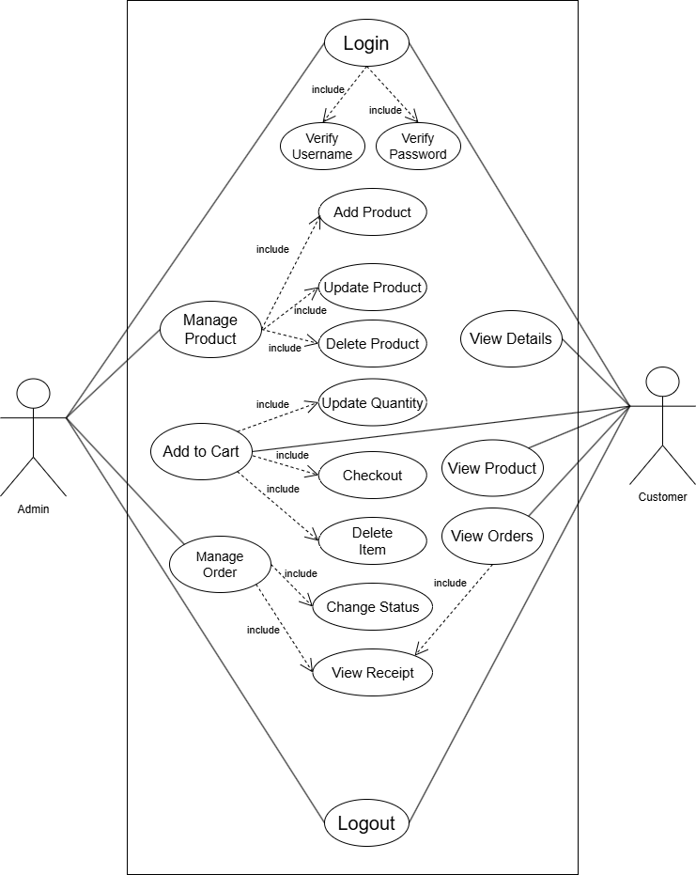

Figure 2.1 Use Case Diagram

Table 2‑1 Use Case Description

|  |  |
| --- | --- |
| Actor | Customer, Admin |
| Description | Customer can log in to the system with email and password. Customer are able to see what's available and buy it. Additionally, the customer has easy access to view their account details, receipts and log out of the system. Admin can manage products and orders after logging in. |
| Data | Data includes the information on products that the customer can order. It also includes the login information of users and customers. |
| Stimulus | The command can be issued by admin i.e. the admin can add new products and categories. |
| Response | For the stimulus provided above, the data table should be updated, upon adding the product. |
| Comment | Only an admin can have the access to the system and all the details or information of products are entered by a admin. |

### Non-Functional Requirement

Non-Functional Requirements are vital elements that influence the overall effectiveness and success of the e-commerce website project. Unlike functional requirements, which focus on specific features and functionalities, non-functional requirements encompass aspects such as user experience, security, affordability, and system performance. The following points outline key non-functional requirements that have been identified to ensure a robust, user-friendly, and efficient e-commerce platform:

* The website incorporates robust security measures to safeguard sensitive user data, transactions, and privacy.
* The website demonstrates fast response times and efficient data processing capabilities to optimize user experience and transaction processing speed.
* The e-commerce website features an intuitive user interface with improved graphical user experience to enhance user interaction and navigation.
* The website operates consistently and reliably, minimizing downtime and system failures.
* The e-commerce website compliance with relevant laws, regulations, and industry standards related to data protection, privacy, and e-commerce transactions.
* The website functions correctly across different web browsers and versions to provide a consistent user experience for all users

## Feasibility Study

The purpose of this feasibility study is to assess the viability and potential benefits of implementing an e-commerce website. The system aims to simplify the process of purchasing products for customers while providing efficient management capabilities for the admin. The feasibility study was conducted by evaluating the technical, economic, operational, legal, and schedule aspects of the system.

### Technical Feasibility

To determine the technical feasibility of implementing the e-commerce website for Your IT Center, thorough analysis of the existing infrastructure was conducted. This involved assessing the readiness of servers, databases, and web development technologies.

### Economic Feasibility

The economic feasibility study involved a detailed cost-benefit analysis. Implementation and maintenance costs of the e-commerce website were calculated, and these were compared with the allocated budget. This analysis included the cost of web development, hosting, and any third-party services required.

### Operational Feasibility

For operational feasibility, the integration of the e-commerce website with the current operational processes of Your IT Center was analyzed. This involved mapping out existing workflows and identifying areas for improvement. User-friendly interfaces and intuitive features were designed to ensure ease of use, minimizing the need for specialized expertise.

### Legal Feasibility

To ensure legal feasibility, all relevant laws and regulations, including data protection, consumer protection, and e-commerce-specific guidelines, were reviewed. Appropriate measures have been taken to ensure the security and privacy of customer information.

### Schedule Feasibility

The schedule feasibility study involved creating a realistic and achievable project timeline. A detailed Gantt chart was developed to outline all project activities, including planning, research, analysis, design, coding, testing, and documentation.

#### Gantt Chart

A Gantt chart, commonly used in project management, is one of the most popular and useful ways of showing activities (tasks or events) displayed against time. On the left of the chart is a list of the activities and along the top is a suitable time scale. Each activity is represented by a bar, the position and length of the bar reflects the start date, duration and end date of the activity. (Nishadha, 2024)

Table 2‑2 Gantt Chart

|  |  |  |  |  |  |  |  |  |  |
| --- | --- | --- | --- | --- | --- | --- | --- | --- | --- |
| **Activities** | Week  1 | Week  2 | Week  3 | Week  4 | Week  5 | Week  6 | Week  7 | Week  8 | Week  9 |
| Planning |  |  |  |  |  |  |  |  |  |
| Research |  |  |  |  |  |  |  |  |  |
| Analysis |  |  |  |  |  |  |  |  |  |
| Design |  |  |  |  |  |  |  |  |  |
| Coding |  |  |  |  |  |  |  |  |  |
| Testing |  |  |  |  |  |  |  |  |  |
| Documentation |  |  |  |  |  |  |  |  |  |

## System Design

System Design for the e-commerce platform involves structuring the various elements essential for its operation, including architecture, modules, components, and interfaces. It is tailored to meet the specific needs and requirements of "Your IT Center" by engineering a cohesive and efficient system. Some of the designs that were considered for the development of “E-commerce website for Your IT Center” are ER Diagram and DFD.

### ER Diagram

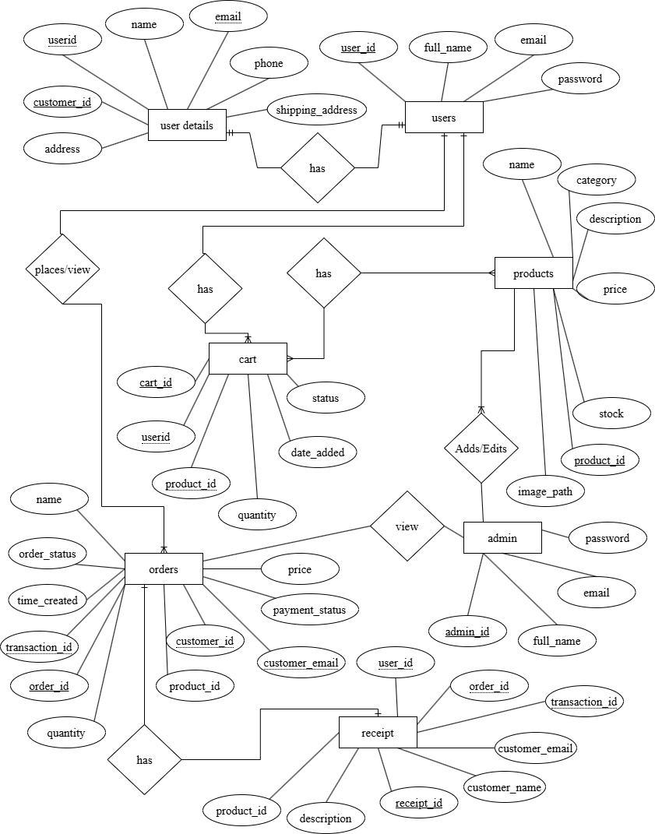

Figure 2.2 ER Diagram

### DFD Diagram

A data flow diagram (DFD) maps out the flow of information for any process or system. It uses defined symbols like rectangles, circles and arrows, plus short text labels, to show data inputs, outputs, storage points and the routes between each destination. (Chart, 2024)

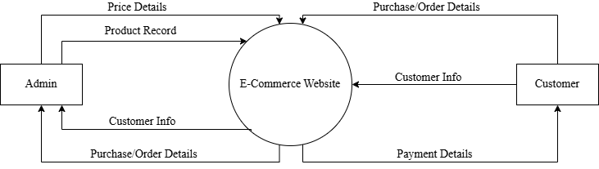

Figure 2.3 DFD (Level 0)

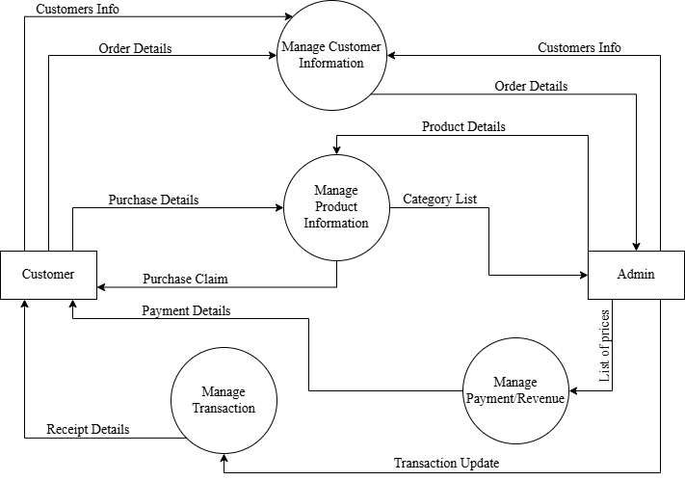

Figure 2.4 DFD (Level 1)

## System Testing

System testing is a crucial phase in the development of the e-commerce website at Your IT Center. This process involves testing the entire system as a whole to ensure that all components work together seamlessly and meet the specified requirements.

### Unit Testing

Unit testing was undertaken after the actual implementation of the system. After development of the system has been completed, testing was also performed. Functionality testing and interface testing combined to ensure the system functionality as requirement.

#### Test Case

Table 2‑3 Test Case 1

|  |  |  |  |  |  |  |  |  |
| --- | --- | --- | --- | --- | --- | --- | --- | --- |
| **Project Name:** E-Commerce Website | | | | | | | | |
| **TEST CASE** | | | | | | | | |
| Test Case ID: TC_01 | | | | Test Designed by: Rohan Phuyal | | | | |
| Test Priority: High | | | | Test Designed Date: 12th Feb, 2024 | | | | |
| Module Name: Add Products | | | | Test Executed by: Rohan Phuyal | | | | |
| Test Title: Add Product from admin panel | | | | Test Execution Date: 28th Sept., 2021 | | | | |
| Description: Adding Products through Admin Panel | | | | | | | | |
| Pre-Conditions: Data is not present in the database. | | | | | | | | |
| SN | Steps | Test  Data | Expected  Result | | Actual  Result | Status (Pass/Fail) | Notes |
| 1 | Admin login | E: rohanphuyal2@gmail.com  P: admin | Dashboard to be displayed | | Dashboard is displayed | Pass |  |
| 2 | Navigate to products tab |  | Products Table to display | | Products Table is displayed | Pass |  |
| 3 | Click on Add Product |  | Add Product form to popup | | Add Product form is displayed | Pass |  |
| 4 | Data input | Fill Form Correctly and attach image. | Verifies data, and shows success message upon success | | Verified data, and showed success message upon success | Pass |  |

**Post Condition:** Product added into the database, and is displayed on the website.

Table 2‑4 Test Case 2

|  |  |
| --- | --- |
| **Project Name:** E-Commerce Website | |
| **TEST CASE** | |
| Test Case ID: TC_02 | Test Designed by: Rohan Phuyal |
| Test Priority: High | Test Designed Date: 12th Feb, 2024 |
| Module Name: Checkout | Test Executed by: Rohan Phuyal |
| Test Title: Checkout | Test Execution Date: 28th Sept., 2021 |
| Description: Placing an order with Khalti as payment method | |
| Pre-Conditions: User is logged in and Item is already added to cart | |

|  |  |  |  |  |  |  |
| --- | --- | --- | --- | --- | --- | --- |
| SN | Steps | Test  Data | Expected  Result | Actual  Result | Status (Pass/Fail) | Notes |
| 1 | Navigate to Cart |  | Cart page to be displayed | Cart page is displayed | Pass |  |
| 2 | Choose Finalize and Pay |  | Payment Option to be displayed | Payment Option is displayed | Pass |  |
| 3 | Choose Khalti |  | Redirect to Khalti payment gateway | Redirected to Khalti payment gateway | Pass |  |
| 4 | Enter your payment details |  | Receipt to be displayed | Receipt is displayed | Pass |  |

**Post Condition:** Product can be viewed from Cart option and saved in database too.

## Findings

The findings from the report highlight the successful development and implementation of a comprehensive e-commerce platform to address the challenges faced by Your IT Center. The project identified the limitations of solely relying on physical store visits for sales and order management, emphasizing the need for an online presence to enhance customer reach and streamline operations. Through systematic phases of requirement gathering, system design, implementation, testing, and deployment, the project successfully delivered an e-commerce website equipped with features like product browsing, searching, secure payment options, and an admin panel for efficient order management and customer data insights. The findings underscore the significance of embracing e-commerce to offer a convenient shopping experience, expand customer base, and improve operational efficiency for businesses in Nepal's evolving e-commerce landscape.

# Discussion and Conclusion

## Discussions

The e-commerce website for Your IT Center, emphasizes how the online platform has effectively addressed the organization's challenges and limitations. The discussion highlights the user-friendly nature of the website, offering customers a seamless shopping experience while empowering the organization with enhanced order management capabilities and valuable insights into customer behavior. Furthermore, the project is recognized not only for meeting the client's objectives but also for serving as a valuable learning experience, showcasing the potential of e-commerce platforms to revolutionize customer experience, increase market reach, and optimize operational processes for businesses in the digital era.

During this summer project, following data and information were discussed:

* Current situation of the organization
* Advantages of using this e-commerce website
* How this e-commerce website can be used efficiently

The e-commerce website has some area yet to cover and some problems to address. However, it will overcome them all in future with new features.

## Conclusion

The project “E-Commerce Website for Your IT Center” is successfully developed and implemented a comprehensive e-commerce website for "Your IT Center." This online platform addresses the identified limitations of relying solely on physical store visits for sales and recordkeeping limiting the store reach with global audience. The website offers customers a convenient and user-friendly online shopping experience, featuring product browsing, searching, and secure payment options. The e-commerce platform ensures that the business can operate 24/7, providing convenience for customers and creating new sales opportunities around the clock. This project not only fulfills the client's objectives but also serves as a valuable learning experience, demonstrating the potential of e-commerce platforms to enhance customer experience, expand reach, and improve operational efficiency for businesses. This project has underscored the importance of adopting technological solutions to stay competitive and responsive to market demands, setting a strong foundation for continued innovation and development.

# References

Chart, L. (2024). *Lucid Chart*. Retrieved from Lucid Chart: https://www.lucidchart.com/pages/uml-activity-diagram

Nishadha. (2024). *What is Gantt Chart?* Retrieved from Gantt Chart: https://www.gantt.com/

PAL, S. K. (2024). *Waterfall Model – Software Engineering*. Retrieved from GeeksForGeeks: https://www.geeksforgeeks.org/waterfall-model/

Paradigm, V. (2024). *Visual Paradigm*. Retrieved from https://www.visual-paradigm.com/guide/uml-unified-modeling-language/what-is-use-case-diagram/: https://www.visual-paradigm.com/guide/uml-unified-modeling-language/what-is-use-case-diagram/

Tutorials Point. (2024). *TutorialsPoint*. Retrieved from TutorialsPoint: https://www.tutorialspoint.com/sdlc/sdlc_waterfall_model.htm

# Appendices

**Appendix 1: Questionnaire**

Dear respondent,

The following questionnaire is designed for the purpose of gathering data pertinent to my summer project titled "**E-Commerce Website** with Reference to **Your IT Center**." Your participation and valuable insights are greatly appreciated, and all information provided will be used solely for educational purposes. Thank you for your cooperation and the time you are dedicating to this endeavor.

Name:  
Age:  
Gender:

1. How do customers currently place orders for your products or services?
2. What methods do you use to handle customer inquiries and orders?
3. What challenges or limitations do you face with your current sales and distribution process?
4. Are there any specific areas where you feel your current methods are inefficient or could be improved?
5. Are there any specific technologies or tools you currently use to manage orders and customer relationships?
6. Are there any specific challenges or limitations the organization faces with its current methods of promotion and sales?
7. Do you currently have an online presence for selling your products/services?
8. What are some common pain points or frustrations your customers face when shopping for PC components in-store?
9. How can the online store address these frustrations and create a more convenient and enjoyable shopping experience?
10. What type of customer data do you currently collect through your physical store?
11. What specific insights or information are you hoping to gain from customer data analysis?

**Appendix 2: Screenshots**

**User/Customers Side**

Home

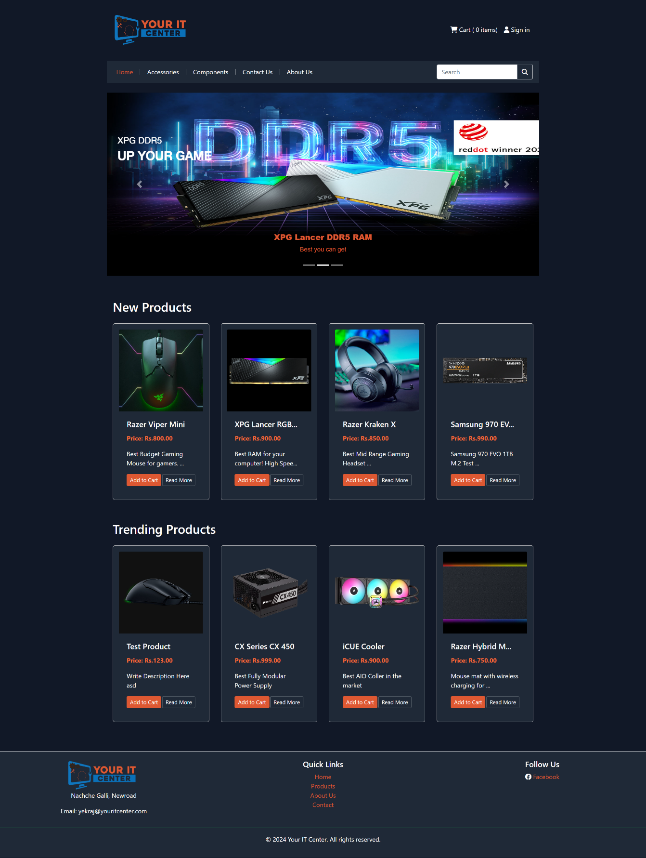

Sign In

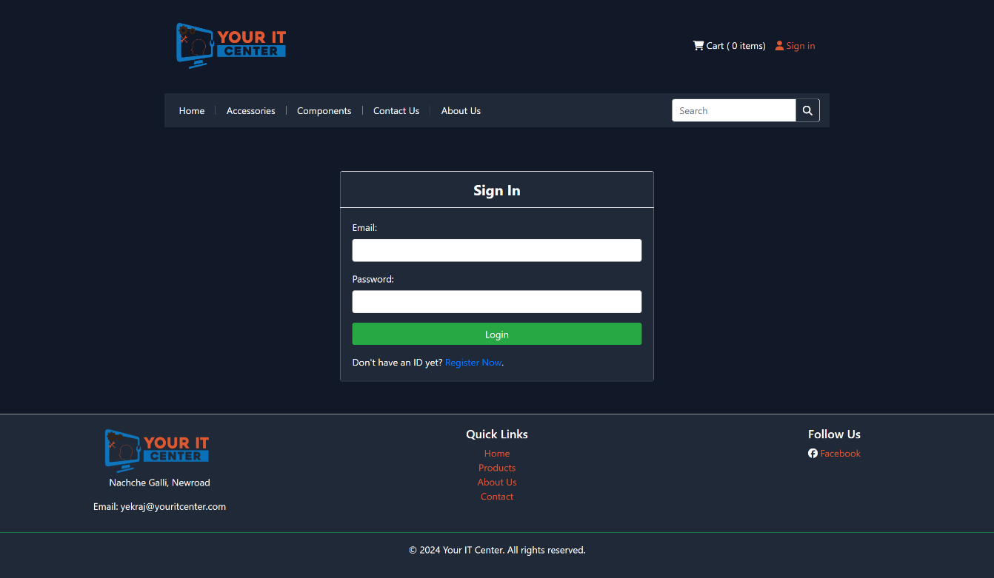

Register

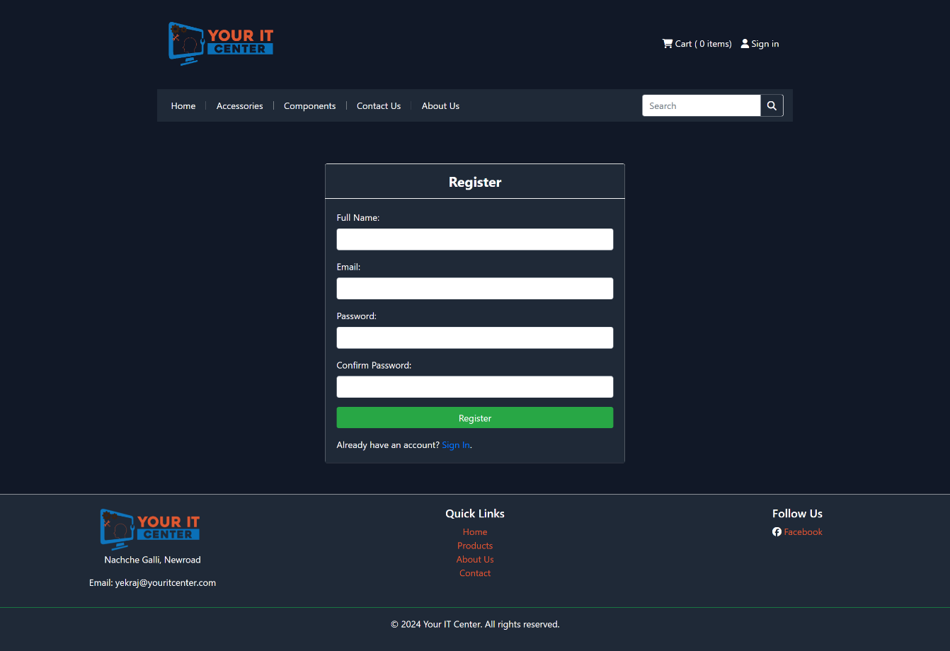

Accessories

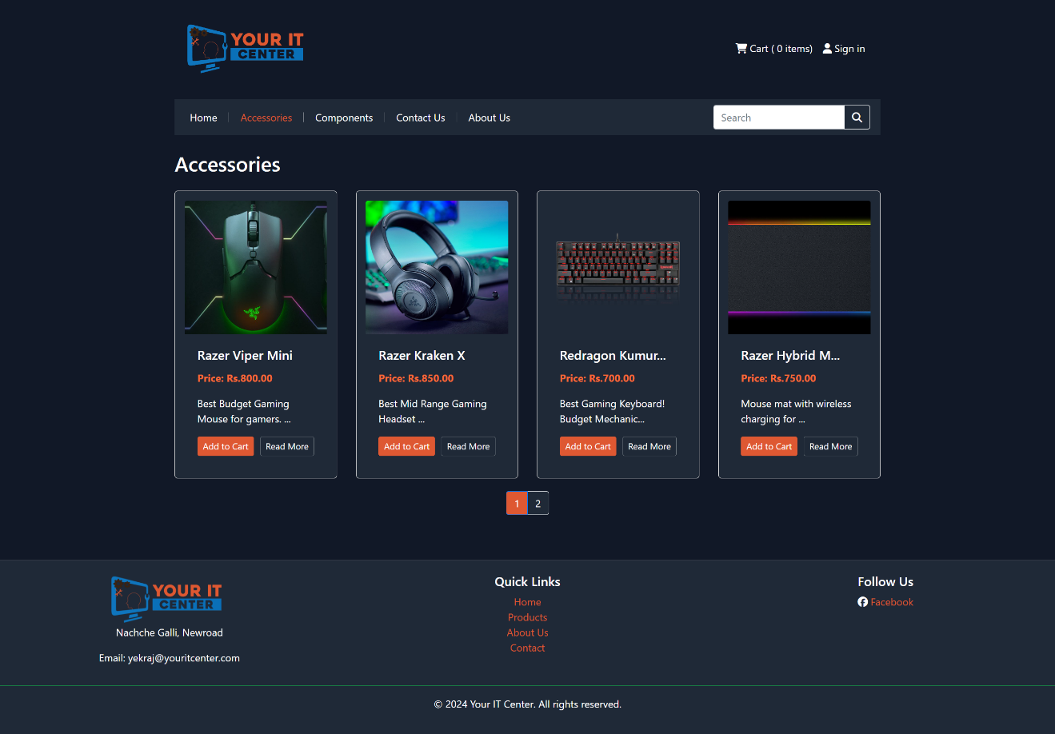

Components

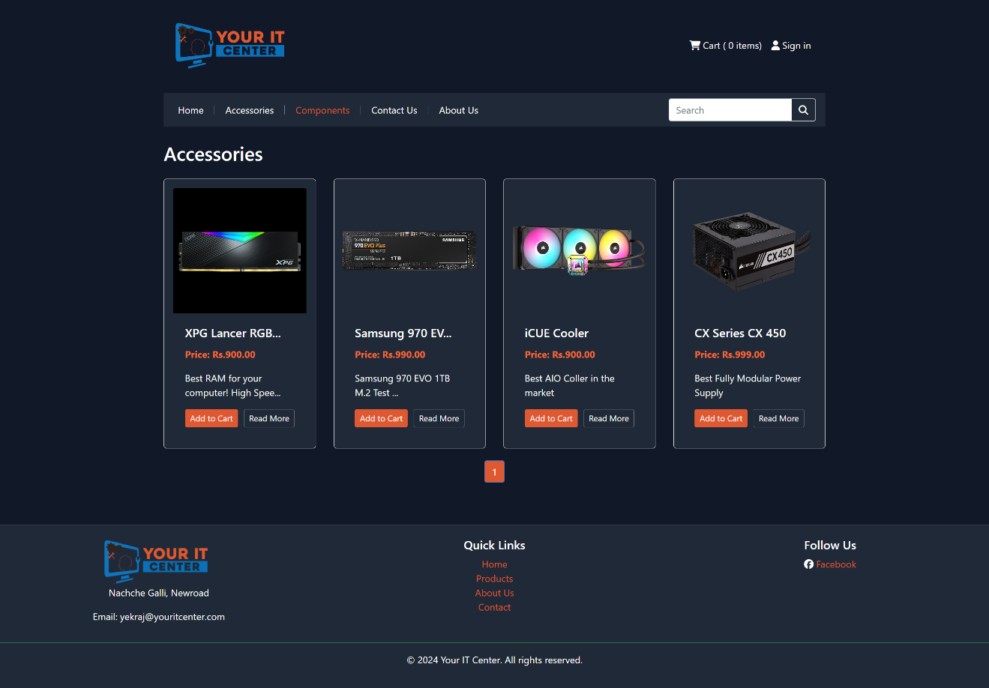

Cart

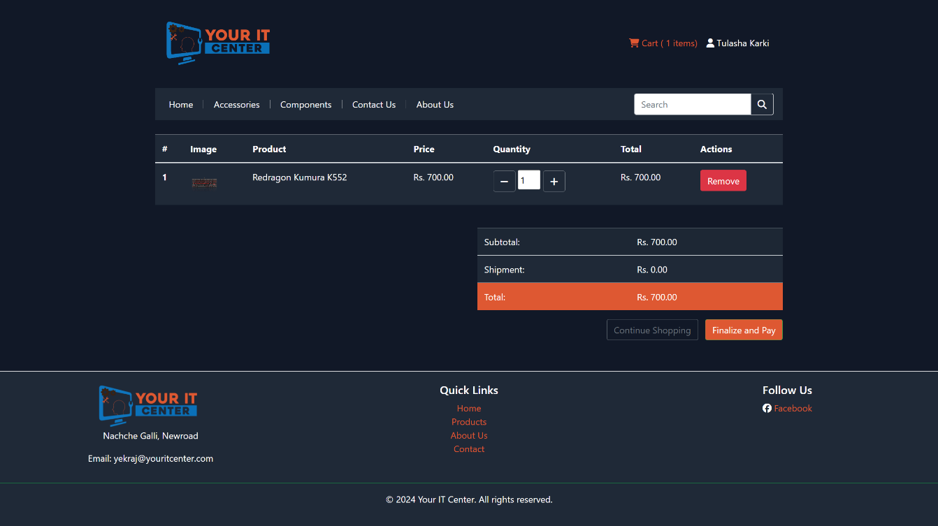

Myprofile

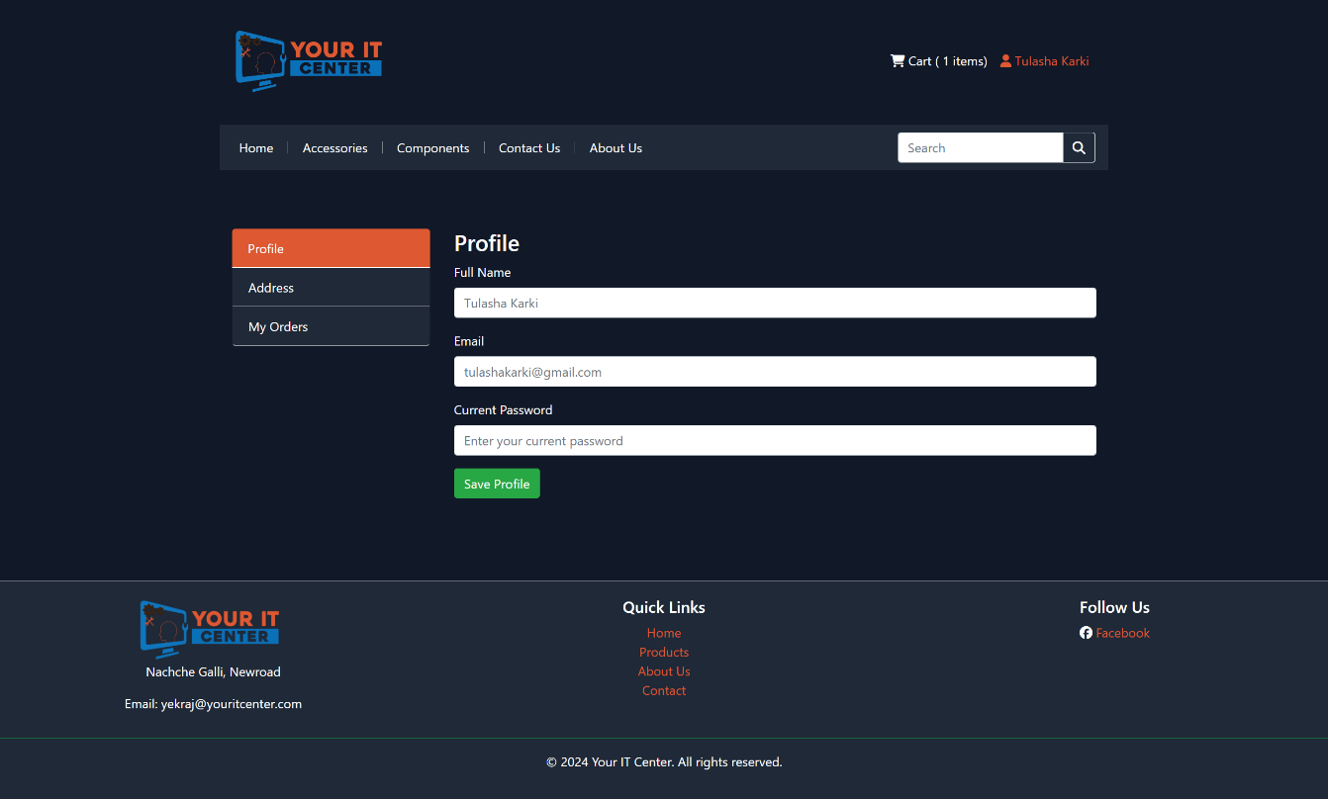

Address

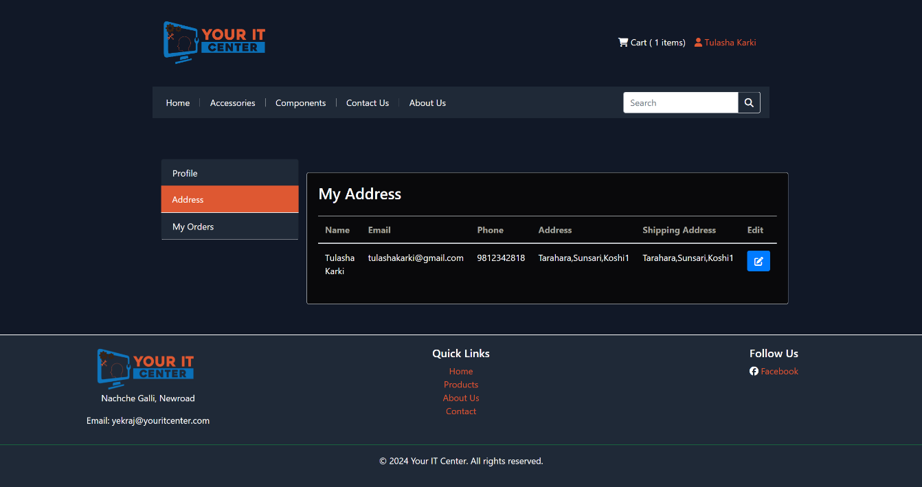

Edit Address

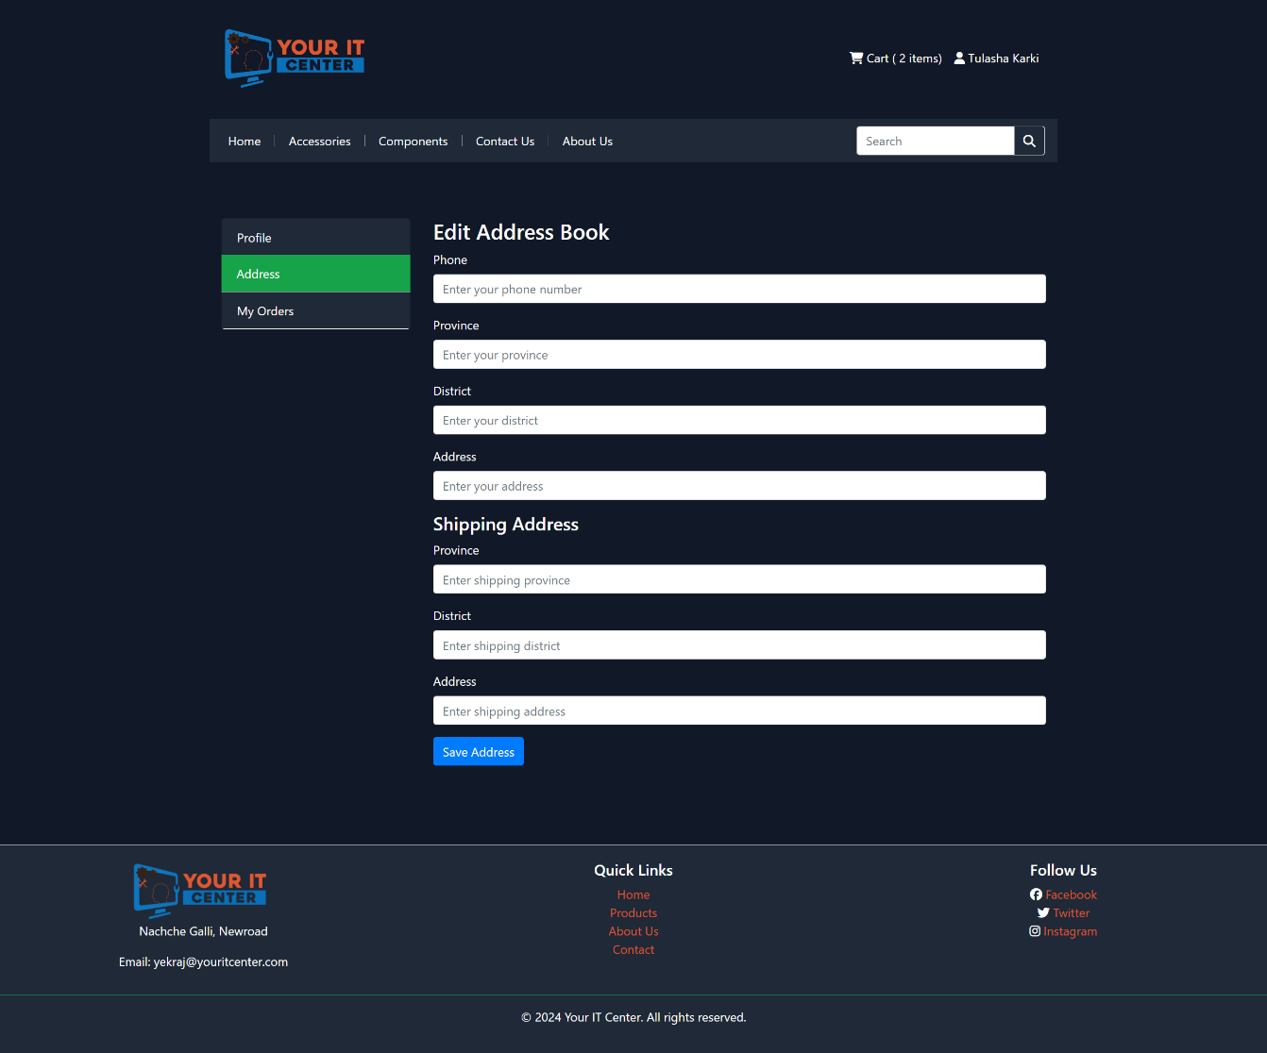

Receipt

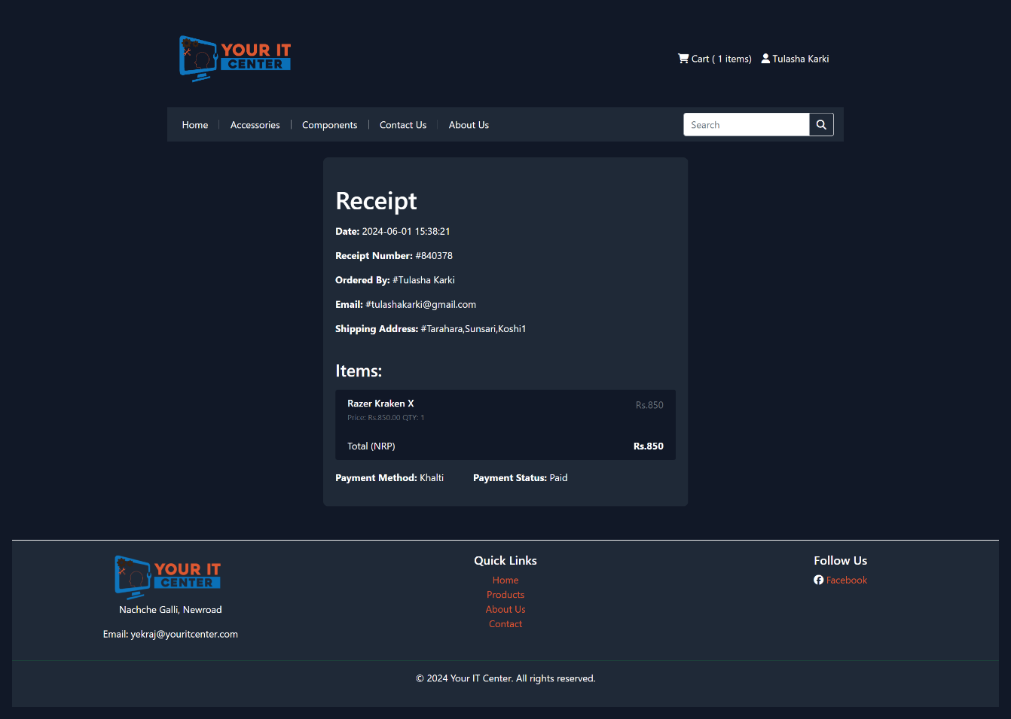

Search

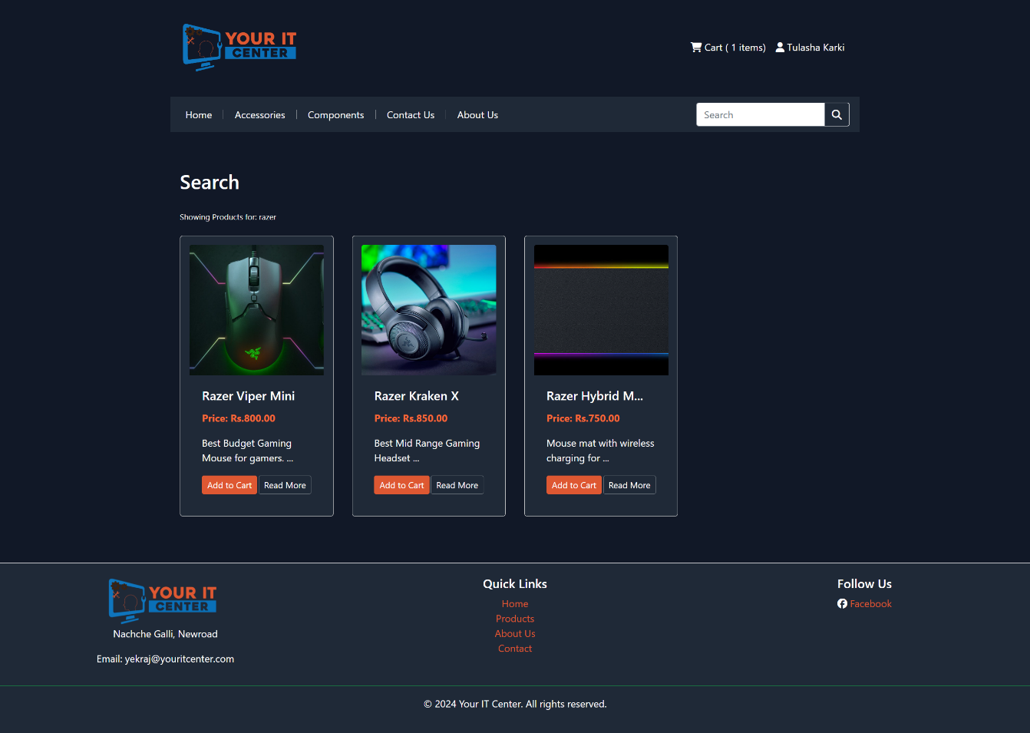

Single Product

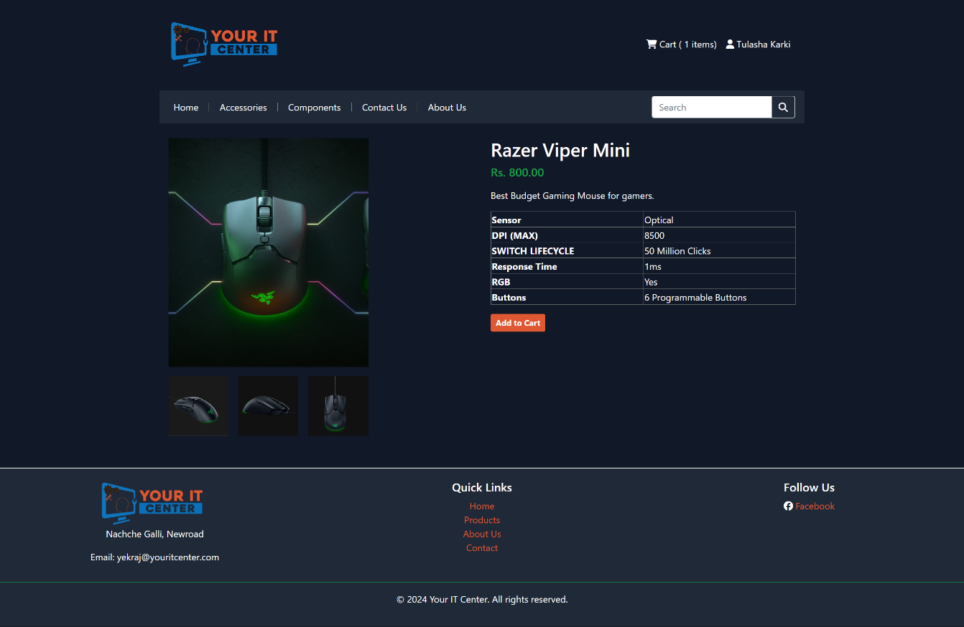

Contact Us

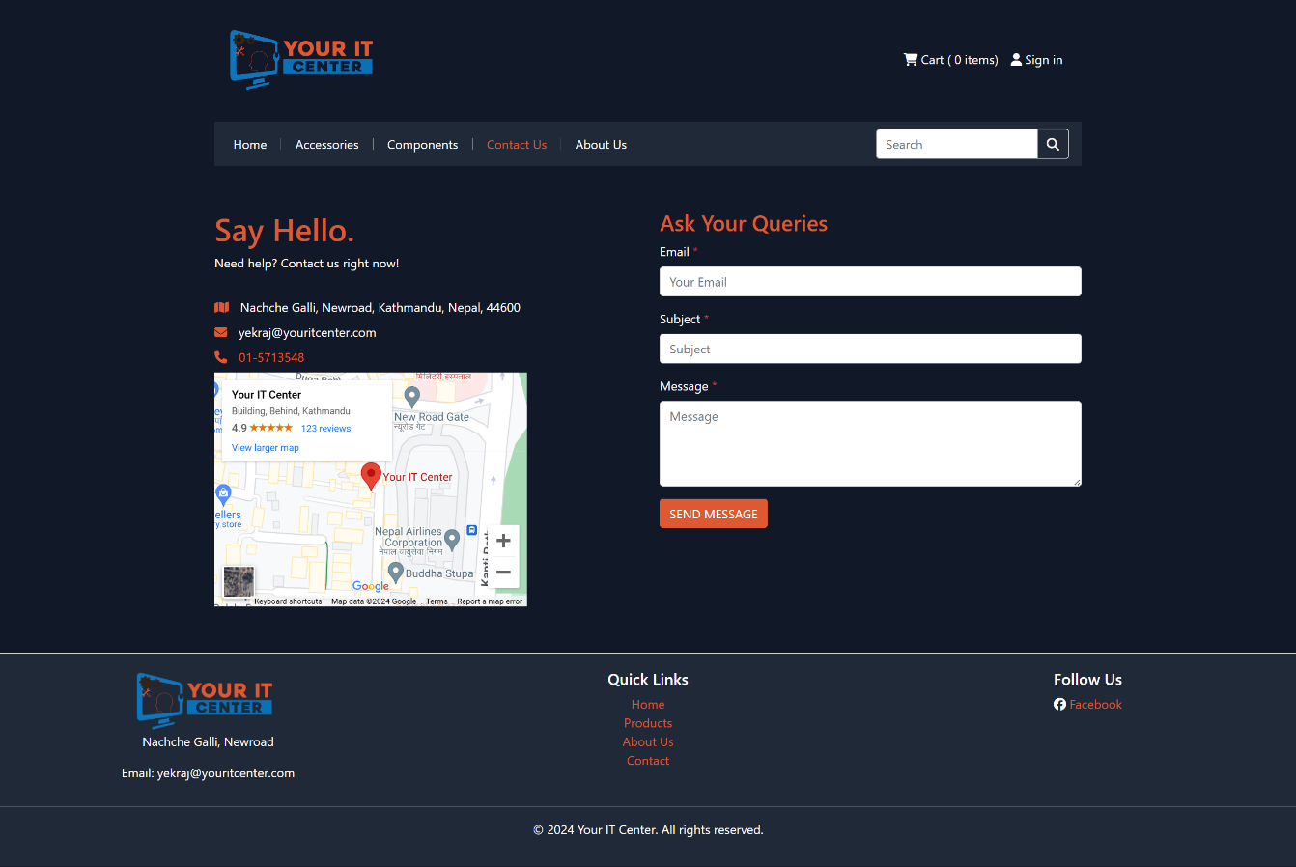

About Us

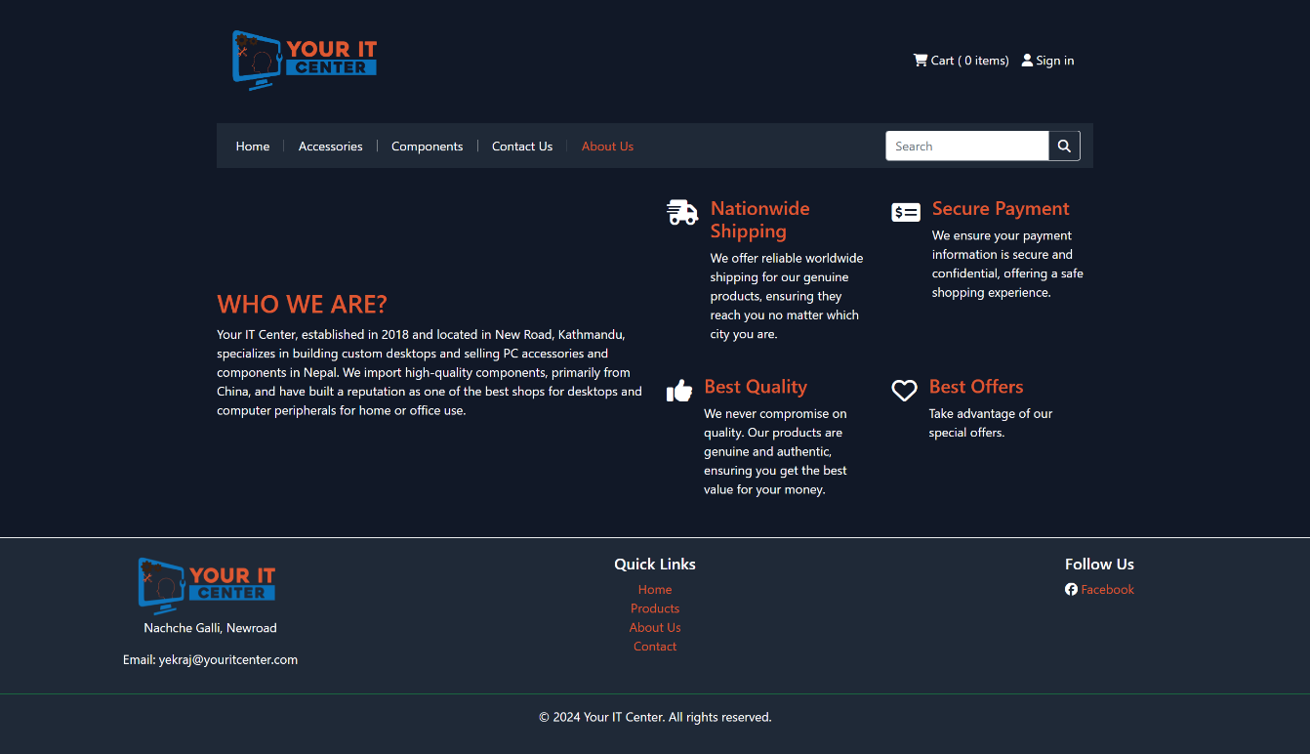

**Admin Side**

Login

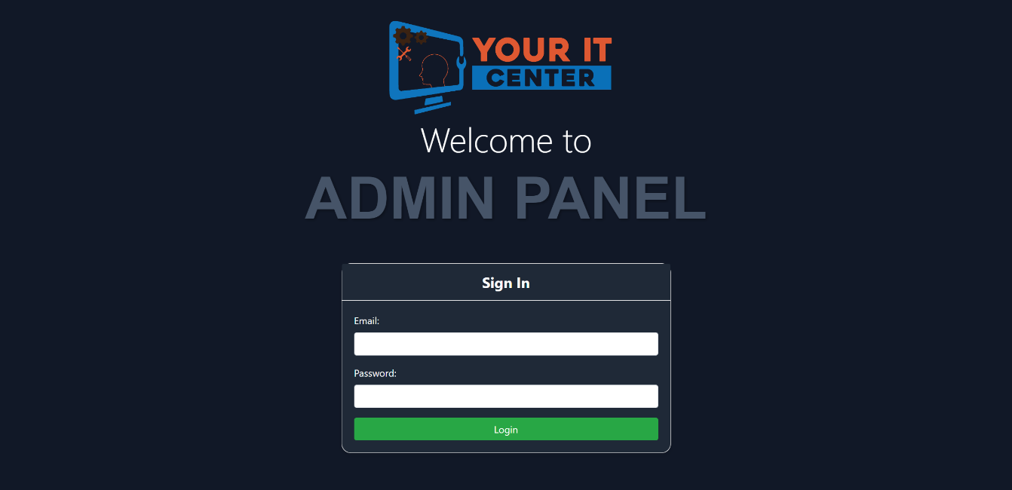

Dashboard

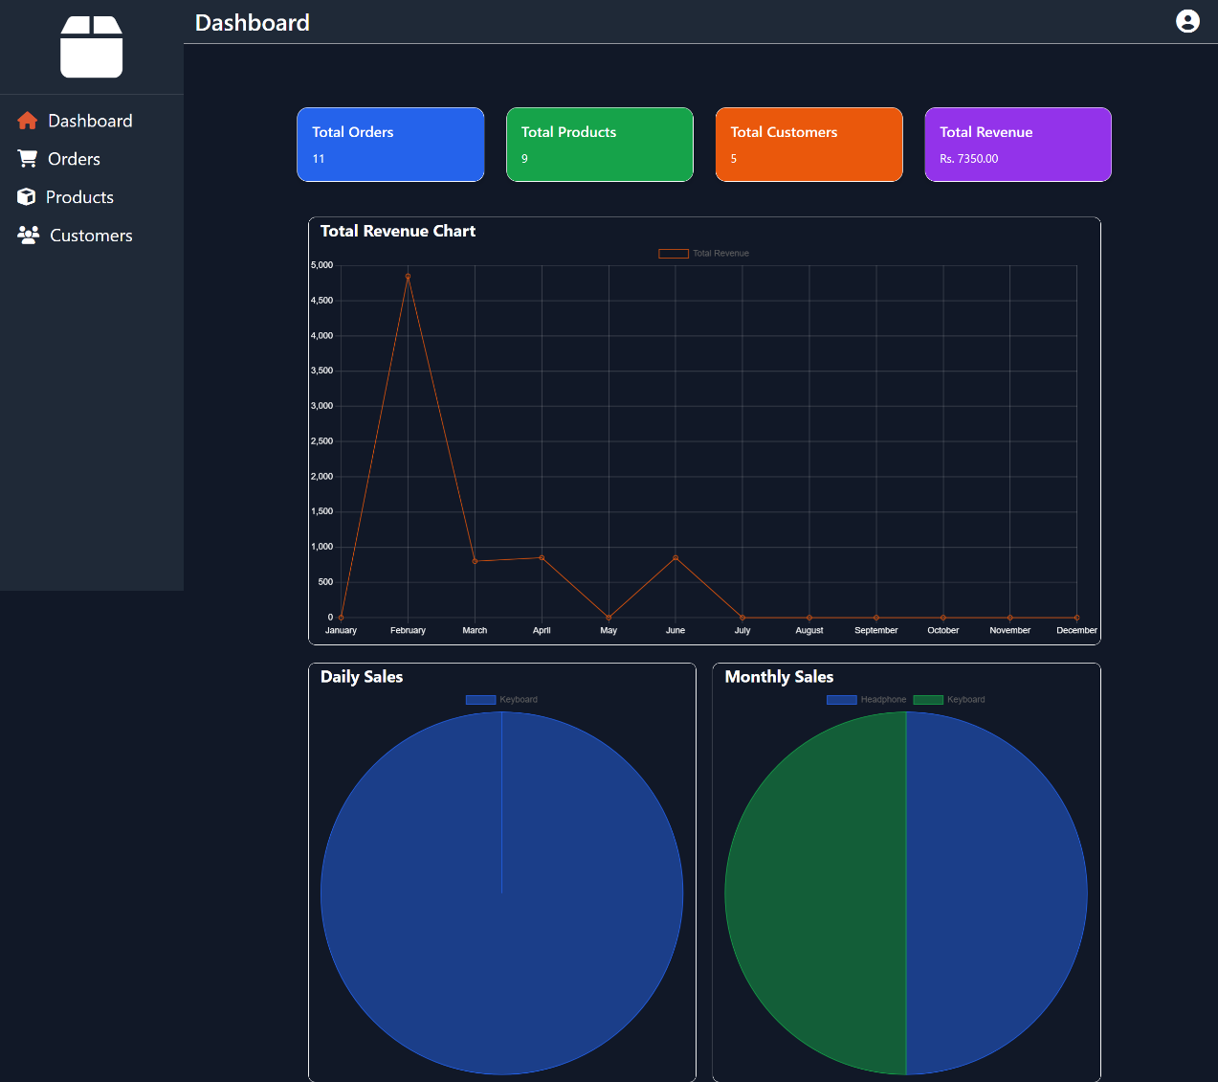

Orders

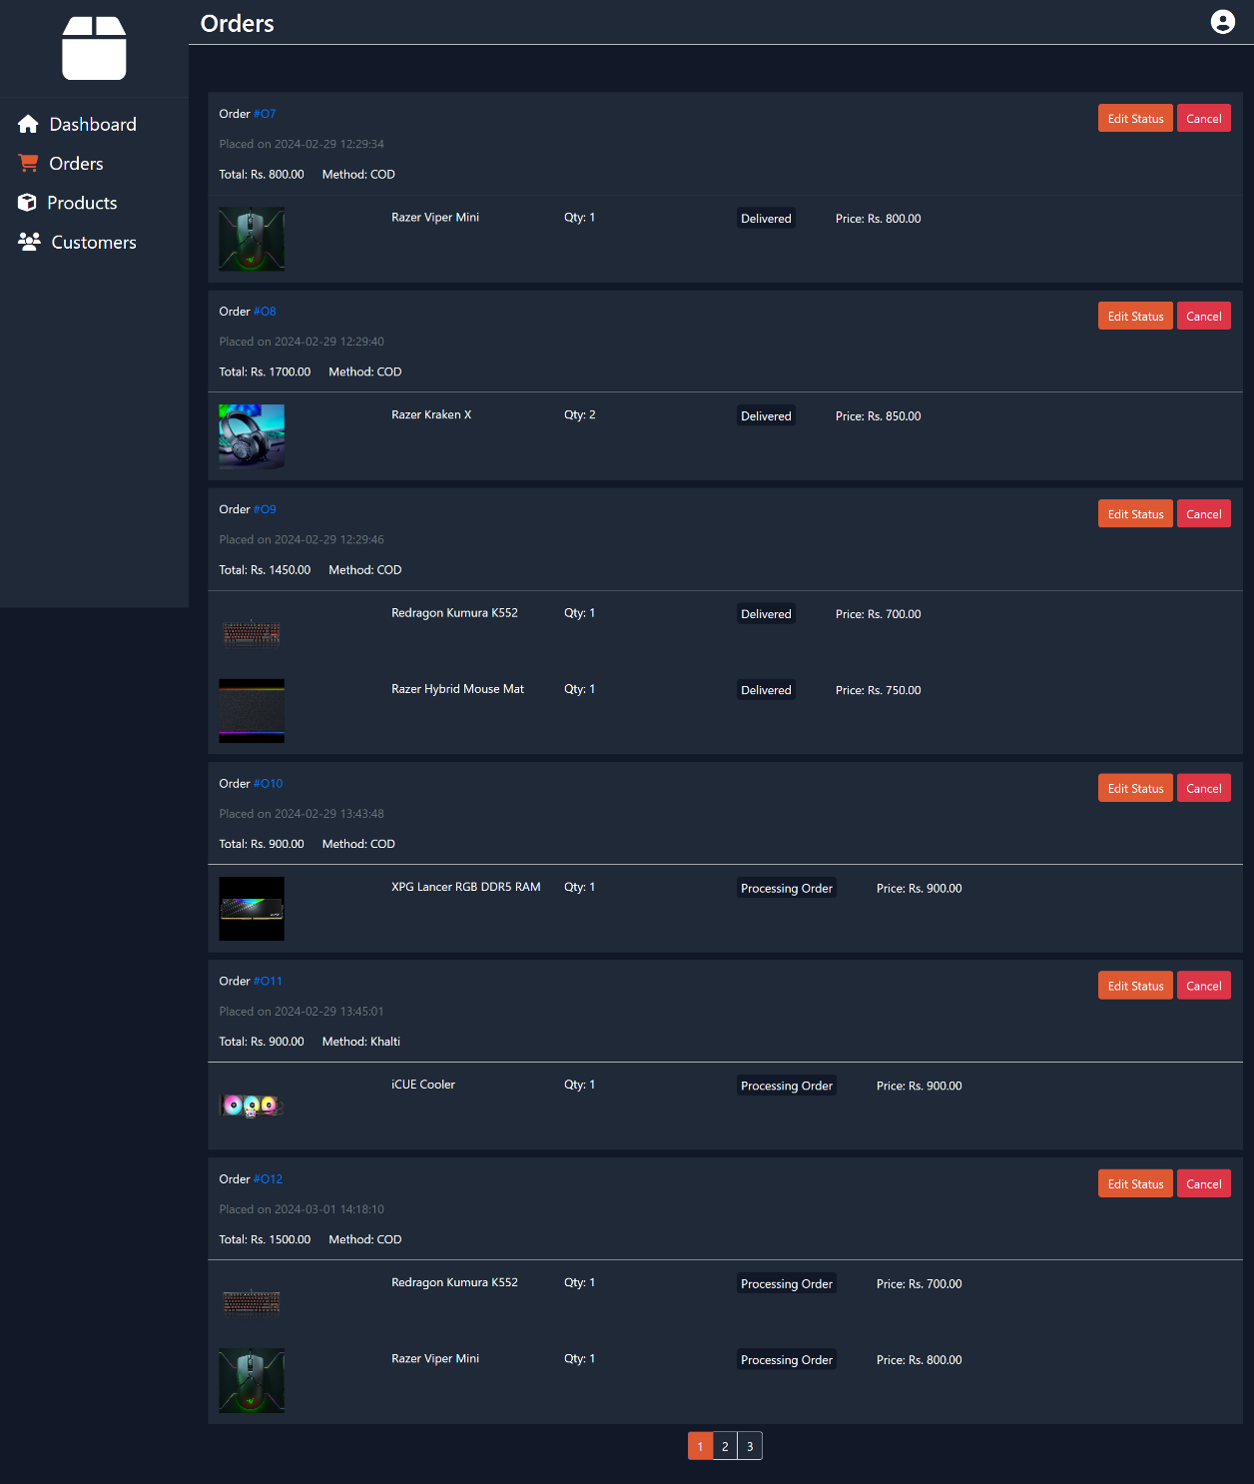

Products

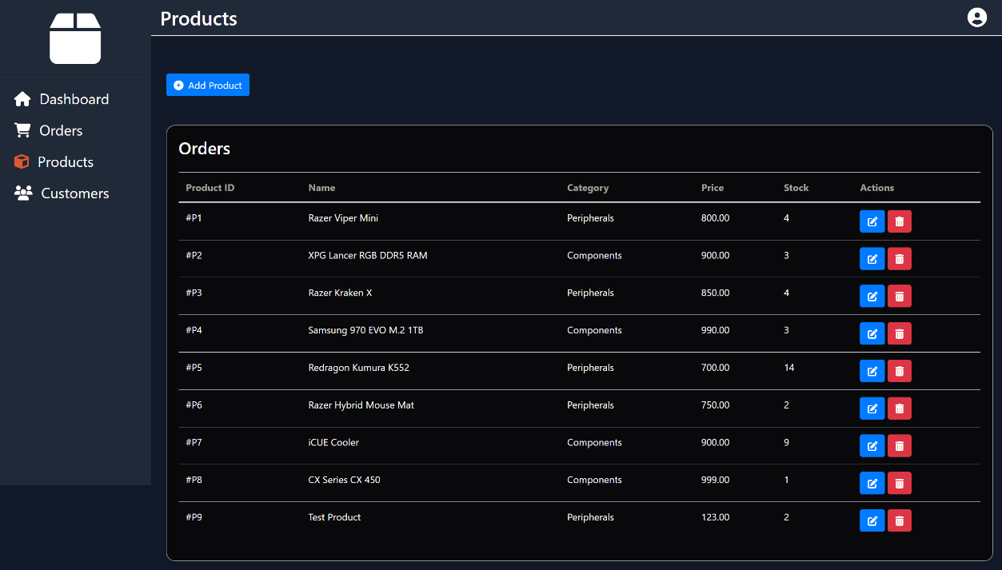

Add Products

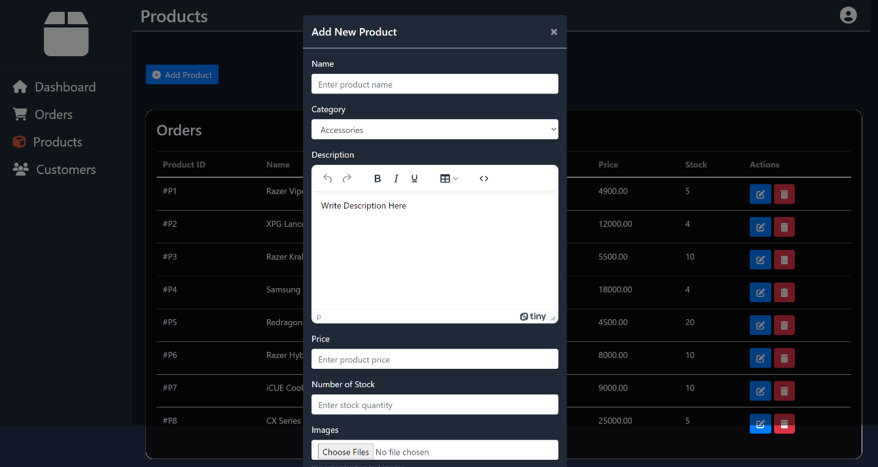

Customers

